# **Course: Object Oriented Programming**

# **Lab 9a**

**Abstraction**

**Task 1:**

Write code using following UML diagram.

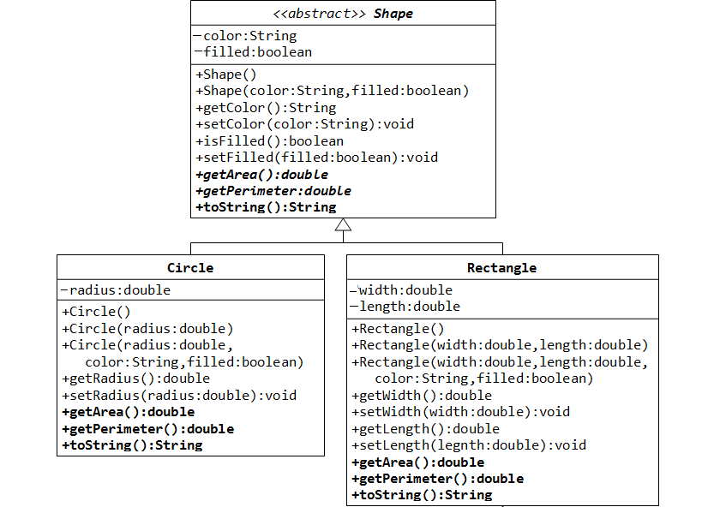

1. Create an array of shapes of 4 elements.
2. Initialize array with elements of different sub-classes (rectangle, circle).
3. Show the user a menu, which shape’s data he wants to change (circle:1, or rectangle:2).
   * Input shape data from user (length, width in case of rectangle, and radius in case of circle)
   * Now inside a loop, set the data of all shapes of input type to input values. E.g. if the user enters 1 for shape (i.e. circle), then 5 for radius of the circle, then the radius of all circle objects in the array should be set to 5. (HINT: You will have to first check for required shape using the instanceof operator, then, you will have to downcast to set appropriate value of the object)
     + Check the desired shape.
     + Downcast the shape in desired shape.
     + Change values according to user input.
     + Set back the array element.
4. Create another static method called shapesSummary(Shape [] s) which displays shapes area, perimeter and prints the shapes using the toString method.
5. In the end, call the shapesSummary method to print the data of all the shapes.

**Expected Output:**

